**Date: 18/08/ 2025**

# Lab Practical #05:

Study the concept of VLAN using packet tracer.

# Practical Assignment #05:

1. **Implement the different network structures in VLAN and VLAN trunking. Also check connectivity between them using ping command or PDU utility.**

**Solution :**

# Steps:

* 1. Open Packet Tracer.
  2. Add 1 Switch + 4 PCs.
  3. Assign IPs:

o VLAN 10 → PC1: 192.168.10.1, PC2: 192.168.10.2

o VLAN 20 → PC3: 192.168.20.1, PC4: 192.168.20.2

* 1. Go to Switch → CLI → Configure VLANs:

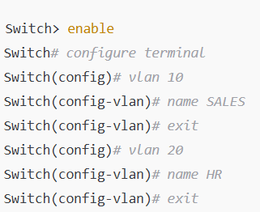

* 1. Assign VLANs to ports:

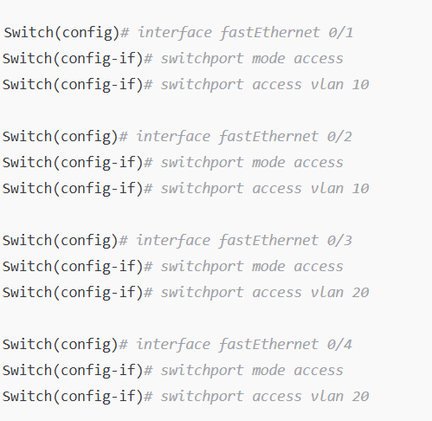

**Date: 18/08/ 2025**

* 1. For VLAN trunking (between switches):

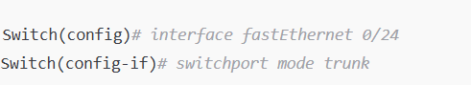

* 1. Test connectivity:
     + PCs in the **same VLAN can ping each other**.
     + PCs in **different VLANs cannot ping** unless a router-on-a-stick or Layer 3 switch is configured.

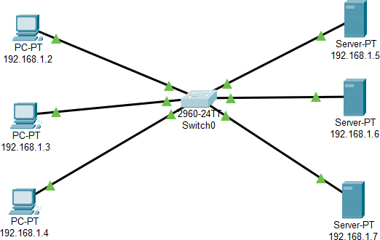

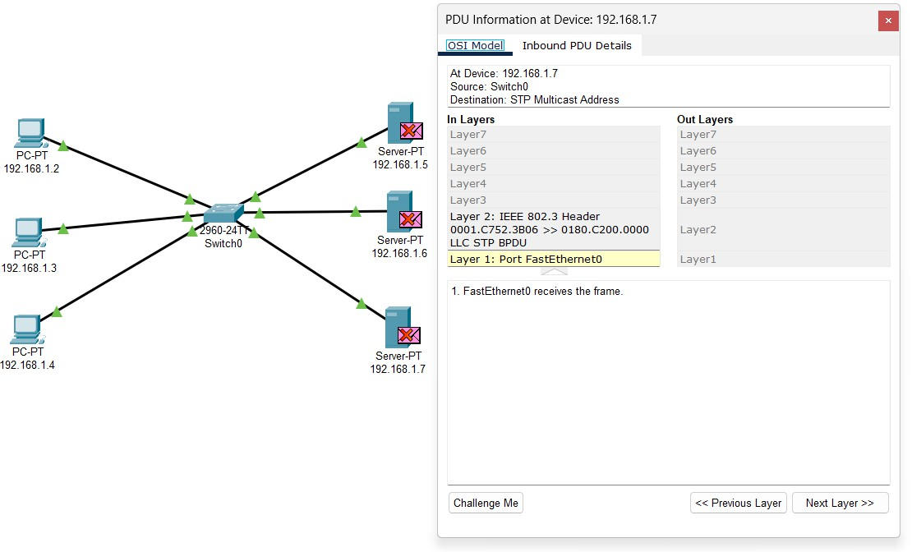

**Date: 18/08/ 2025**

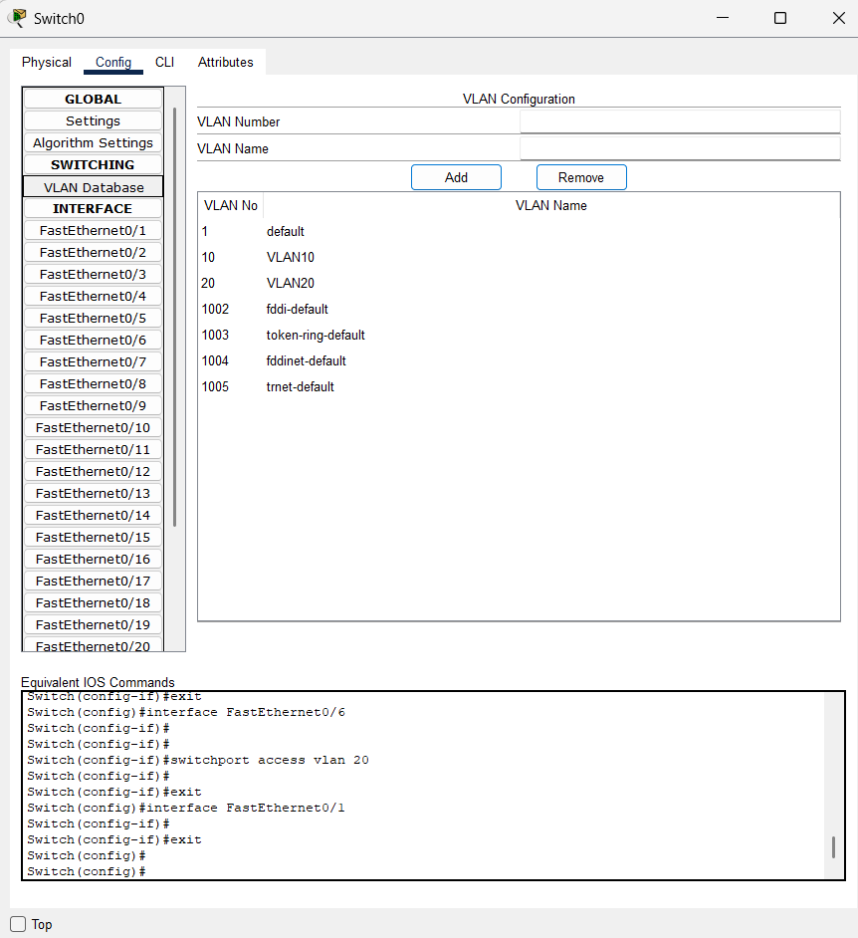

Here we setup VLAN database add VLAN number and name

**Date: 18/08/ 2025**

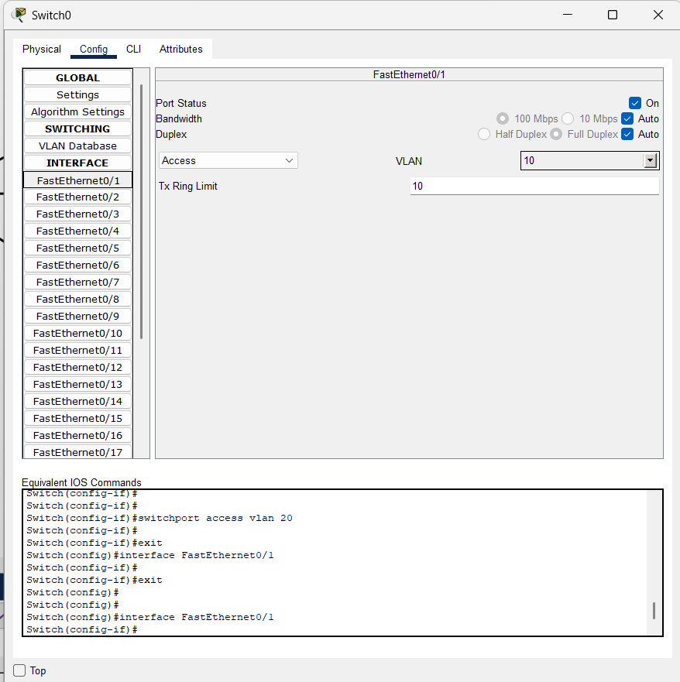

Here we setup the switch ,set vlan10->10 and vlan20->20

**Date: 18/08/ 2025**

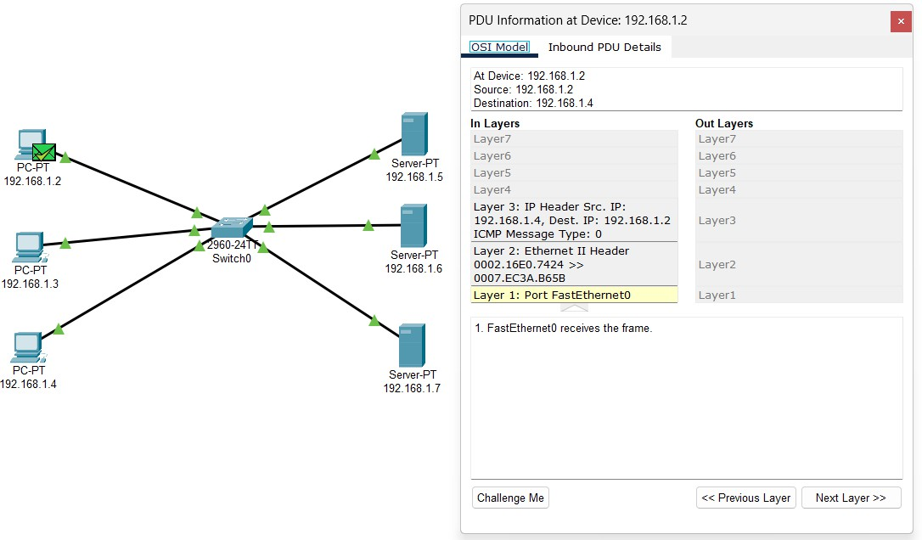

**Date: 18/08/ 2025**

Other VLAN NETWORK SCREENSHOTS OR LABWORK

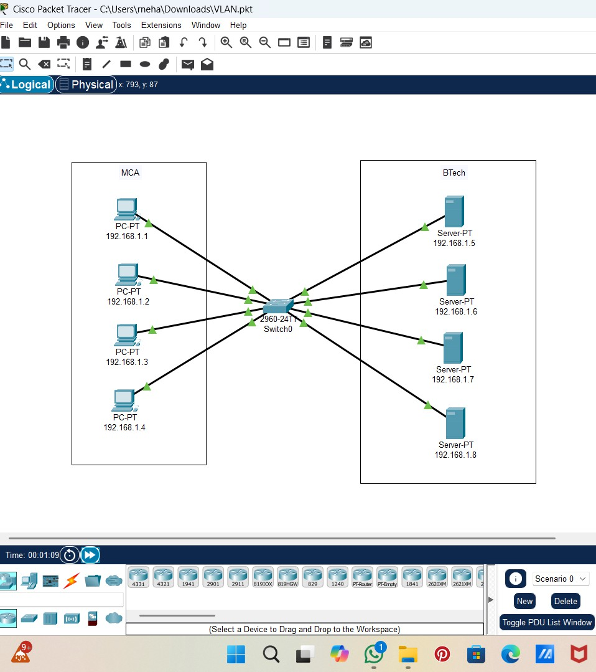

**Date: 18/08/ 2025**

